CPS 2004 ASSIGNMENT REPORT

VIOLETA AI NAHARRO ZALDIVAR
ID. 2311251

TABLE OF CONTENTS:
- UML
  - Approach
  - Classes
  - Repositories
- C++
  - User guide
- Java
  - User guide
- References

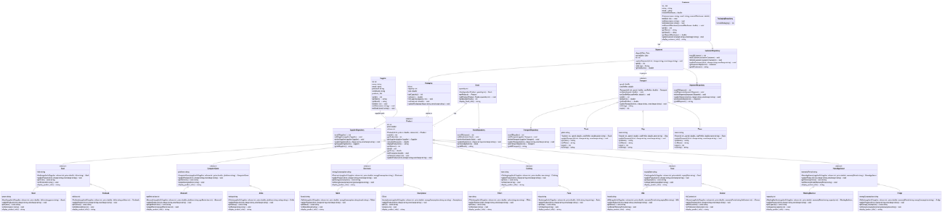
- UML

In case the image it’s not clear I’ll put the link of the image from above here

